**LAB # 2**

**Q1.**

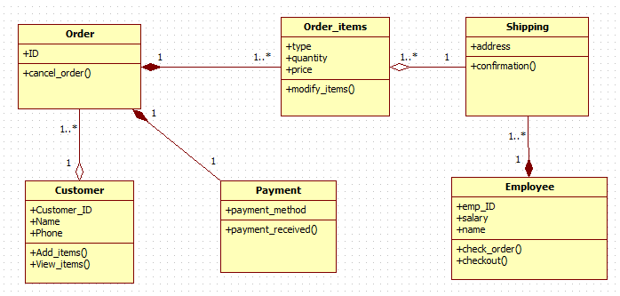

**Q2.**

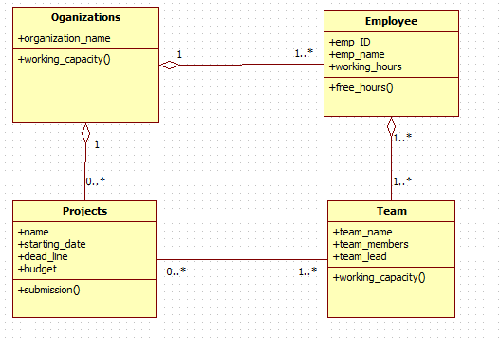

**Q3.**

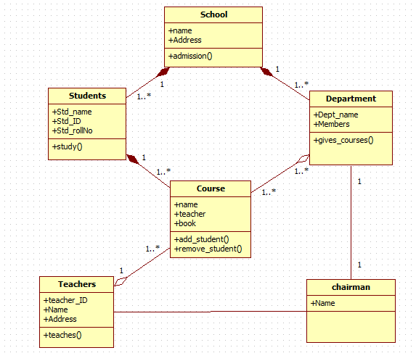

**Q4.**

**EXPLANATION:**

If student is eligible and has average marks so student can enroll in 1 to many seminar, he can attend seminars and can take parking pass. One to many students can enroll for seminar, zero to many students can be on waiting list for 0 to many seminars. Students can have zero to one address. Address can be validated and can use as output label. Professor can also have 0 to 1 address. Professor can get parking pass and information. 0 to one professor can have 0 to many seminars and can get offer for course.

**Q5.**

**EXPLANATION:**

One customer can order many items. Customer can be a corporate customer or a personal customer. One order can have many order items and one item can be in a quantity, many order line can have one products. Name, delivery, address, phone and credit rating of a customer is private. Date received and when the order is prepaid, and price of the order is private. Quantity of order line is also private. Product name and price is also private.

**Q6.**

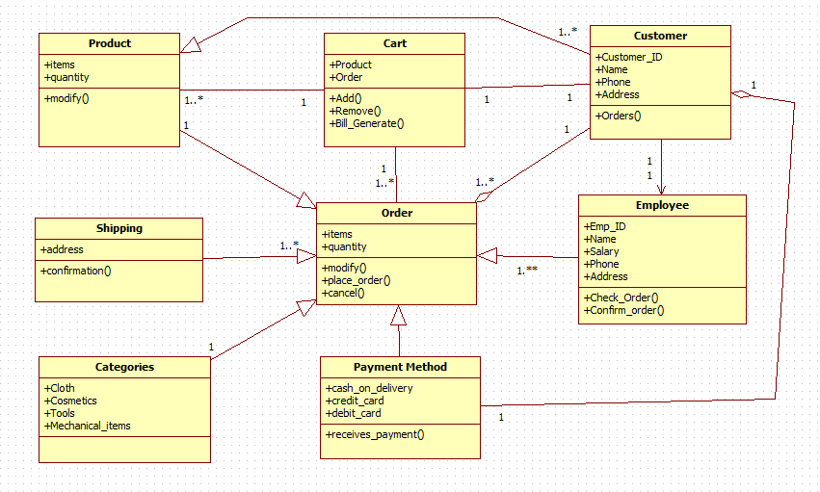

**Q7.**

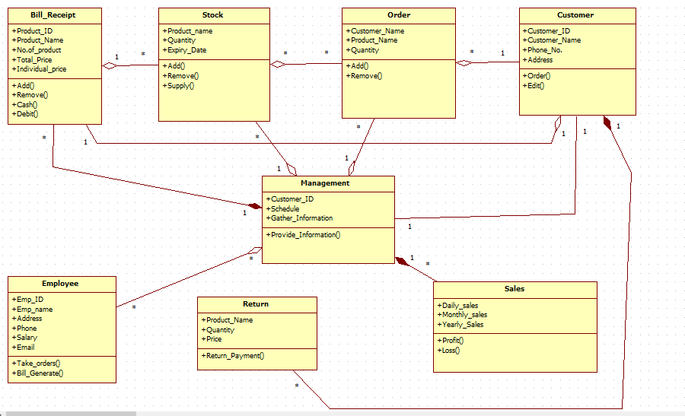

**Q8.**

